DFRS-BFRB-044.docx (rev. 10/23)
 |  | Wisconsin Department of Agriculture, Trade and Consumer Protection  Division of Food and Recreational Safety  P.O. Box 93296, Milwaukee, WI 53293-0296  datcpfrbsupport@wisconsin.gov |  |  |  |  |  |  | Wis. Stat. § 97.605
Recreational and Educational Camp
Written Lifeguard and Attendant Staffing Plan
Use of this form is recommended to meet recreational and educational camp written lifeguard and attendant staffing plan requirements. Pursuant to Wis. Admin. Code § ATCP 78.26(3)(c)2., the camp shall keep a copy of the plan on the premises and the plan shall made available for review by the department or its agent. Failure to maintain a staffing plan is subject to compliance action under Wis. Admin. Code ch. ATCP 78. The plan shall include all of the following:
- A diagram of recreational areas of water used by campers (excluding licensed swimming pool and vendor provided)
- Designated areas for each aquatic program activity including boating, swimming diving:
ie. Aerial photo, satellite view mapping, or hand drawn diagram
- The hours of operation; how is adequate artificial lighting provided if an area is operated beyond daylight hours?
Time Open: |  |  |  |  |  | Time Ends:
Swimming does not occur beyond daylight hours
- Indication of how visual obstructions are addressed by lifeguard placement (note example on page 2)
- The location of each first aid kit in the vicinity of waterfront:
- A method of communication between lifeguards and attendants:
Whistle |  |  | Walkie Talkie | Other:
- A description of a reliable communication system used to reach 911 from the waterfront:
The number of lifeguards and attendants per Wis. Admin. Code § ATCP Table 78.26 Lifeguard and Attendant Staffing Per Activity for each aquatic program activity, including off-premises aquatic program activities, such as where boating, canoeing, swimming, or water skiing occurs:
Example. Note: “visual obstruction” means, in reference to aquatic program activity, a feature that is manmade or natural and is on, in or near the water, that is larger than 10 feet in length by six feet in height by fivefeet in width and that obscures a lifeguard or attendant’s line of sightManmade visual obstructions can include a variety of inflatables, piers and docks or natural obstructions from treeline. |  |  |  |  |  |  | 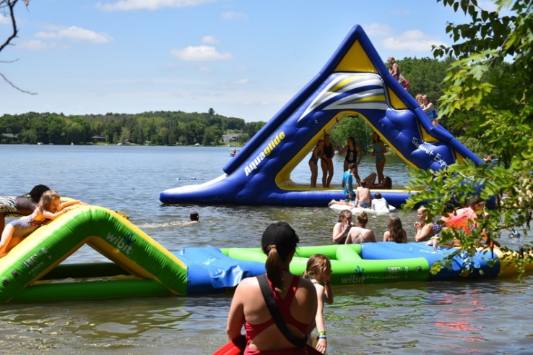
Personal information you provide may be used for purposes other than that for which it was originally collected. Wis. Stats. §15.04(1)(m)

