Meat or Poultry Raffle
Fact Sheet
Raffle Licensing
Individuals and for-profit businesses such as taverns and restaurants are not permitted to conduct raffles under Wisconsin law. Organizations permitted to conduct raffles include local religious, charitable, service, and fraternal or veterans’ organizations, who have been existence for at least one year prior to applying for a license, or chartered by a state of national organization that has been in existence for at least three years.
Wisconsin Department of Administration (DOA) issues licenses required to conduct raffles. For answers to frequently asked questions, or to apply for a new raffle license, visit https://doa.wi.gov/Pages/LicensesHearnings/RaffleLicense.aspx.
Food Handling Licensing
Did you know that non-profit organizations conducting meat raffles may need a retail food establishment license? A meat or poultry product requiring refrigeration is considered a Time/Temperature Control for Safety Food, meaning these foods must be refrigerated or frozen to prevent the potential growth of pathogenic bacteria.
A non-profit organization conducting a meat raffle shall ensure they are properly licensed or exempt from obtaining a retail food license. In most cases, a non-profit organization can sell prepackaged Time/Temperature Control for Safety Foods up to 12 days a year without needing to obtain a retail food license. Please contact Wisconsin Department of Agriculture, Trade and Consumer Protection’s (DATCP) Bureau of Food and Recreational Business Specialists to discuss your specific situation by calling (608) 224-4923 or via email to: datcpdfslicensing@wisconsin.gov.
Food Safety Considerations for Meat or Poultry Products

Meat and poultry products offered as part of a meat raffle must bear the mark of inspection. Eligible meat products can
be obtained directly from a licensed meat establishment, or from a retail food establishment selling pass-through meat
products bearing the legend. If purchasing products from a retail establishment, ensure the retailer did not further
process the products by verifying original package bearing the legend is intact.


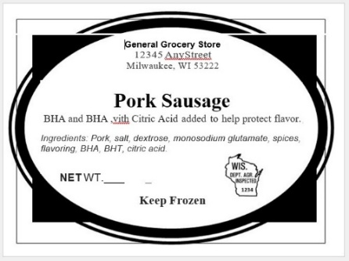
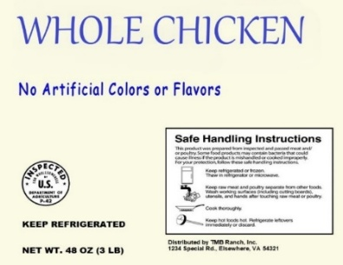
Example Inspection Legends:

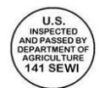

Store and handle the products in a safe and sanitary manner, ensuring proper temperatures are maintained. Products
are to be kept frozen or refrigerated at 41℉ or below.
For more information and resources regarding meat or poultry labeling requirements for products being offered in meat raffles, please call (608) 224-4694 or email datcpmeatpoultrylicensing@wisconsin.gov.

