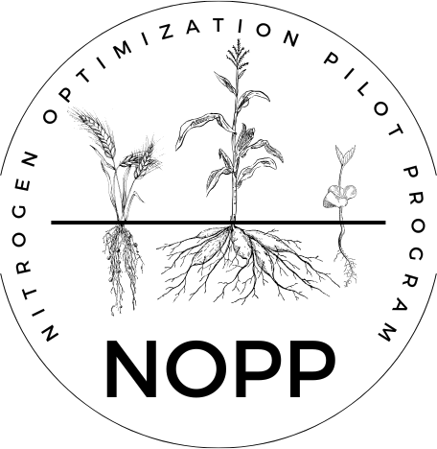
Nitrogen Optimization Pilot Program
Intent to Apply

Provide basic information about your proposed NOPP research project by answering the questions below. Project details do not need to be final at this state, as this form serves as a starting point to help guide and refine the project moving forward. We encourage applicants to reach out to Monica Schauer (NOPP Research Director) early in the process to assist with developing your research proposal before the deadline. We are here to help applicants turn a nitrogen related research question into a well-designed project that will provide meaningful data.


Submit the form to monica.schauer@wisc.edu by December 19, 2025. Proposals will be promptly evaluated, and further guidance will be given for fine-tuning the project. Final NOPP applications will be due January 16, 2026.

Note that there are three different project options to choose from, as indicated on the RFP. Options 2 & 3 are smaller-scale projects that are limited to first-time applicants only. Please refer to the RFP for specific project details.

Project Applicant
Name | Click or tap here to enter text.
Phone number | Click or tap here to enter text.
Email | Click or tap here to enter text.

Which research project do you propose? (CHOOSE ONE AND ANSWER QUESTIONS BELOW FOR THE OPTION YOU CHOOSE)

For options 1 & 3, please attach a draft plot plan or sketch for the research project. Reach out to Monica Schauer for assistance if needed.

☐Option 1: Full Nitrogen Rate Trial (4 rate minimum if investigating additional management practice (with and without cover crop, manure, etc.), 6 rate minimum if N rate trial with no additional management factor, maximum award of $40,000 per producer)
How many agricultural producers will be part of this project? Please list the likely participants.
Click or tap here to enter text.
What is the research question you would like to investigate?
Click or tap here to enter text.
What nitrogen rates do you plan to use?
Click or tap here to enter text.
If you are investigating an additional management practice, please describe.
Click or tap here to enter text.
Other than the required sampling, what additional sampling do you plan to include in your project (reference RFP for requirements)?
Click or tap here to enter text.

☐Option 2: Nitrogen Use Efficiency Assessment (maximum award of $2,500 per producer)
With the requirement to have at least 3 producers for this project, how many agricultural producers will be part of this proposed project? Please list the likely participants.
Click or tap here to enter text.
Other than the required sampling, what additional sampling do you plan to include in your project (reference RFP for requirements)?
Click or tap here to enter text.

☐Option 3: Two N rates with management practice (maximum award of $5,000 per producer)
How many agricultural producers will be part of this proposed project? Please list the likely participants.
Click or tap here to enter text.
What is the research question you would like to investigate?
Click or tap here to enter text.
What nitrogen rates do you propose to use?
Click or tap here to enter text.
What additional management practice will you investigate?
Click or tap here to enter text.
Other than the required sampling, what additional sampling do you plan to include in your project (reference RFP for requirements)?

