ARM-LWR-456 (Rev. Dec 2021)
Wisconsin Department of Agriculture, Trade and Consumer Protection
Division of Agricultural Resource Management
P.O. Box 8911
Madison, WI 53708-8911
Phone: (608) 224-4611

2023 Agricultural Enterprise Area Petition

The undersigned persons hereby petition the Wisconsin Department of Agriculture, Trade and Consumer Protection (DATCP), pursuant to s. 91.86, Wis. Stats., to create an Agricultural Enterprise Area (AEA) under s. 91.84, Wis. Stats. We have read the guidance provided and submit the following information in support of the petition:
PETITION CHECK LIST
Petitions are due to DATCP by July 28, 2023. Submit an electronic copy to DATCPWorkingLands@Wisconsin.gov of the following:
This completed petition form (including any supporting pages and documentation)
A map of the proposed AEA (PDF format)
Spatial location/GIS shapefile data used to create map (emailed ZIP file)
A signed signature page for each owner of an eligible farm who is signing the petition
A political subdivision signature page signed by an authorized officer or representative of every political subdivision (county, town, city or village) in which any part of the proposed AEA is located
A signature page for the county conservationist
Non-petitioner cooperator signature pages or letters of support

PETITION INSTRUCTIONS
Who Can Complete the Application:
A petition application can be completed by one or multiple individuals interested in creating an AEA for their community, however, we highly recommend that the petition is split up among multiple individuals and one person assigned as the petition lead contact. The lead contact will be in charge of putting together all the portions of the petition filled out by the other contributors and submitting the full application to DATCP. Contributors can include any combination of community members, petitioning landowners, local officials, community organizations, municipality staff, and county staff.
Proposed AEA Petition Interview Process:
In order to accurately capture the community voice of each petition, a recorded interview will be conducted during the petition process. This recorded interview will be between 15 and 20 minutes and will be shared with the petition evaluation committee during the petition review process. To schedule your interview, please contact DATCP staff at DATCPWorkingLands@wisconsin.gov.
Filling out the Petition Application:
At the beginning of each section and subsection of the petition there will be instructions to follow when filling out the necessary information. If you have any questions about the instructions or the questions in any section, please contact DATCP staff at DATCPWorkingLands@wisconsin.gov.
Petition Application Timeline:
The Petition application process includes public outreach, petitioner education, community involvement, map making process, and an evaluation. It can take a few months to fully complete a petition application. A sample timeline for submitting an AEA petition can be found in Appendix A at the back of this application.
Both DATCP and County staff may be able to offer support in the petition application process. If you are interested in petitioning for a new AEA for your community, please contact DATCP staff at DATCPWorkingLands@wisconsin.gov and your county Conservation Department (county contact information found within the WI Land + Water Directory).
Application continued on the next page.
1. GENERAL INFORMATION
INSTRUCTIONS:
- Choose a name for the AEA that is relevant to the petitioners or agricultural resources in the area.
- Indicate where the proposed AEA will be located.
- Record the number of acres in the proposed AEA boundary. There are no size restrictions for new AEAs, however DATCP must give preference to proposed AEAs 1,000 acres or more. DATCP may only designate 2 million AEA acres statewide, therefore DATCP may require the proposed boundary be adjusted for designation.
- The petition must be jointly filed by at least 5 eligible farm owners within the boundaries of the proposed AEA, and by each county, town or municipality in which any part of the proposed AEA is located. They must sign a signature page attached to the back of this application. Digital signature pages are available at Petitioning for Agricultural Enterprise Area (AEA) Designation.
PROPOSED NAME OF AEA

COUNTY/COUNTIES IN WHICH PROPOSED AEA IS LOCATED | TOWNS, CITIES OR VILLAGES IN WHICH PROPOSED AEA IS LOCATED
TOTAL ACRES IN PROPOSED AEA | TOTAL NUMBER OF ELIGIBLE PETITIONERS

2. PETITION CONTACT INFORMATION
INSTRUCTIONS:
- Fill out the County Staff contact information. This person will serve as DATCP’s main county contact during the petition and evaluation process.
- Fill out the Landowner Representative. This person should be one the petitioners and will serve as DATCP’s main landowner contact during the petition and evaluation process. This person should be ready and willing to answer questions and provide additional information for the petition if needed.
- Indicate the names and contact information of any individual, not already indicated above, who also contributed to the petition application process. If no other contributors, please leave blank.
COUNTY STAFF CONTACT | EMAIL | PHONE NUMBER
MAILING ADDRESS STREET | CITY | STATE | ZIP
LANDOWNER REPRESENTATIVE | EMAIL | PHONE NUMBER
MAILING ADDRESS STREET | CITY | STATE | ZIP
PETITION CONTRIBUTER | EMAIL | PHONE NUMBER
PETITION CONTRIBUTER | EMAIL | PHONE NUMBER
PETITION CONTRIBUTER | EMAIL | PHONE NUMBER

Application continued on the next page.
3. ELIGIBILITY REQUIREMENTS
INSTRUCTIONS:
Answer the following questions. If “No” is selected for any question, this application is currently ineligible. Questions resulting in “No” should be addressed prior to submitting the application. DATCP is willing assist you in resolving any issues in order to facilitate an AEA petition.
- All parcels in the proposed AEA are located within a farmland preservation area designated in the certified county farmland preservation plan. | Yes | No
- All parcels in the proposed AEA are contiguous*. | Yes | No
- The proposed AEA is primarily in agricultural use. | Yes | No
- At least 5 eligible farm owners signed the “Petitioning Landowner Signature Page(s)” | Yes | No
*Contiguous means “adjacent to or sharing a common boundary.” For the purpose of AEA designation under s. 91.84, Wis. Stats. Parcels that are only separated by a lake, stream, transportation or utility right-of-way are contiguous. Parcel boundaries that meet at a single point are not contiguous.

Application continued on the next page.
4. BACKGROUND INFORMATION
INSTRUCTIONS:
Fill in the following background information of the proposed AEA. Provide as much detail as possible in order to create a clear picture of the area where the AEA is proposed. Assume everyone on the evaluation committee is unfamiliar with the community and local culture of your proposed AEA. You may include maps and photos to support your narrative. Additional instructions are included under each subsection.
A. PROPOSED AEA AREA INTRODUCTION
INSTRUCTIONS:
Write a clear, detailed narrative describing the local agricultural community. As part of the narrative, discuss the local agricultural culture, history, and general importance of this area. You can also include challenges faced by the local agricultural community. Use this introduction to tell the evaluation committee the importance of the agricultural or rural identity within the proposed AEA boundaries.
B. CURRENT LAND USE AND LAND USE TRENDS
INSTRUCTIONS:
While filling out the following information, consider citing existing information or maps from the county’s farmland preservation plan or local comprehensive plans.
- Describe ALL current land uses (both agricultural and non-agricultural) within the proposed AEA OR attach a current land use map with a table or short narrative that explains what the map depicts. For assistance in creating a land use map, please contact DATCP staff at (608) 224-4611 or DATCPWorkingLands@Wisconsin.gov.
- Provide information about land use trends in and around the AEA. This can include, but not limited to, information about development trends, number of new septic systems, population growth, infrastructural changes, agricultural trends, local zoning , protected natural areas, and external pressures to agriculture.
- Select ALL of the main types of agricultural production and agricultural activities within the proposed AEA. Provide a short description where applicable.
CURRENT LAND USE WITHIN THE AEA

LAND USE TRENDS IN AND AROUND THE AEA

TYPES OF AGRICULTURAL PRODUCTION (Select all that apply)
Row Crops (specify)  Specialty Crops (specify)  Vegetable (specify)  Organic (specify) | Grazing  Dairy  Beef  Other Livestock (specify) | Federal Conservation Programs (specify)  State Conservation Programs (specify)  Local Conservation Efforts (specify)  Other (specify)
C. LAND USE CONTROLS AND PLANS IN PROPOSED AEA
INSTRUCTIONS:
Select ALL of the land use controls and plans in the proposed AEA. Provide a short description, map or additional information where applicable.
Farmland preservation zoning ordinance
Subdivision ordinances
Other zoning ordinances (Manure Storage, Livestock Facility Siting, Wellhead protection, etc.) (specify)
Purchase of development rights and/or easements (donated or purchased)
Transfer of development rights
Farmland preservation agreements
Cooperative boundary agreements/inter-municipal agreements
Natural area protections or conservation program activities (state and/or federal) (specify)
Comprehensive plan (specify)
Other programs or activities showing a commitment to water quality and/or soil health (specify)
- CONSERVATION COMPLIANCE
Agricultural performance standards used help to reduce agricultural non-point source pollution of surface water resources, to protect agricultural resources including farmland soils, surface waters, and groundwater, protect air quality, and keep applied nutrients in the soil for plant growth. Conservation compliance is monitored by the county conservation department. Your local county conservation department should be your main point of contact when filling out this section.
INSTRUCTIONS:
- Indicate the approximate level of petitioner conservation compliance within the proposed AEA.
- Provide a brief rational describing the factors contributing to this level of conservation compliance (or lack thereof).
LEVEL OF PETITIONER CONSERVATION COMPLIANCE
Nearly all petitioners are in compliance
More than half of the petitioners are in compliance
Half or less than half of the petitioners are in compliance
Few or no petitioners are in compliance
Compliance status of petitioners is unknown
FACTORS CONTRIBUTING TO LEVEL OF CONSERVATION COMPLIANCE

Application continued on the next page.
5. PURPOSE AND RATIONALE
INSTRUCTIONS:
Fill in the following information for the purpose and rationale for the proposed AEA. Provide as much detail as possible to justify the creation of this proposed AEA. Since DATCP may only designate 2 million AEA acres statewide, use this section to justify to the evaluation committee why this proposed AEA should be a part of this 2 million AEA acres. You may include maps and photos to support your narrative. Additional instructions are included under each subsection.
A. MAIN JUSTIFICATION FOR PROPOSED AEA
INSTRUCTIONS:
State the main justification for creating the proposed AEA and preserving the agricultural land use in the area. Consider including information about land use conflicts, development pressures, promotion of conservation practices, interest in preserving farmland or rural character of proposed AEA, interest in tax credit and conservation compliance, and other external pressures contributing to the desire to preserve farmland.
B. GOALS FOR AGRICULTURAL PRESERVATION AND AGRICULTURAL DEVELOPMENT
INSTRUCTIONS:
- State the specific goals for agricultural preservation, development, and/or innovation. Include goals, plans, and agreements planned to promote economic sustainability, resilience and/or growth within the proposed AEA.
- Explain how you plan to enact the goals identified for the proposed AEA. Briefly described ALL activities including in person or virtual meetings with landowners, planned investments, grants, development incentives, cooperative agreements, land or easement purchases, public outreach activities, and any other activity that supports the proposed AEA’s goals.
GOALS FOR AGRICULTURAL PRESERVATION AND DEVELOPMENT

PLANS TO MEET AGRICULTURAL PRESERVATION AND DEVELOPMENT GOALS

C. PROPOSED AEA BOUNDARY
INSTRUCTIONS:
Describe the decision making process and the information used to draw the boundary of the proposed AEA. Factors used to determine the proposed AEA Boundary should not be limited to subjective criteria (i.e. landowner personal interests). You should consider and include objective criteria such as watershed boundary, soil types, historical land use, future land use plans, and proximity to agricultural infrastructure. Please note that the AEA boundary MUST follow parcel lines and be contiguous. This means that the boundary contains parcels that are connected and are not otherwise separated except by roads, utility right-of-ways or bodies of water.
See Appendix B for additional information on creating an AEA boundary.

Application continued on the next page.
6. PETITION PUBLIC PROCESS AND OUTREACH
INTRODUCTION:
Provide information about the public outreach strategy that was used during the petition development process as well as the future process to encourage landowner participation within the AEA if designated. You may include any flyers, advertisements, informational/educational materials or photos from your public process to support the narrative. Additional instructions are included under each subsection.
A. AEA PETITION PUBLIC PROCESS
INSTRUCTIONS:
Describe the process used to involve the public within the petition process and publicly share information about the proposed AEA, establish the boundary, identify farm owner petitioners, identify non-petitioning co-operators, and notify non-petitioners within the proposed boundary. Provide details on the number and dates of public meetings held (both virtual and in person), number of mailings, door-to-door outreach efforts, newspaper advertisements or articles, and/or any other efforts made to connect with the community.
B. FUTURE OUTREACH STRATEGY
INSTRUCTIONS:
- Describe a future outreach strategy to encourage landowners to participate in the proposed AEA, sign Farmland Preservation Agreements, and achieve conservation compliance. Include details about any virtual or in person future informational meetings, mailings, one-on-one meetings, nutrient management planning classes, and/or any other future efforts made to promote the proposed AEA.
- Establish a reasonable Farmland Preservation Agreement sign-up goal for the AEA if designated. This could be a number of agreements or a percentage of AEA covered by agreements.
OUTREACH PLANS TO MEET AGRICULTURAL PRESERVATION AND DEVELOPMENT GOALS

FARMLAND PRESERVATION AGREEMENT SIGN-UP GOAL

C. CURRENT AND FUTURE OUTREACH ACTIVITIES WITHIN THE PROPOSED AEA
INSTRUCTIONS:
Provide specific examples of current and future outreach activities within the proposed AEA that will be used to promote the proposed AEA, promote investment, economic development, partner collaboration, conservation education, and farmland preservation. Include activities conducted by any key collaborators (such as UW Extension, NRCS, local land trusts, citizen groups, and producer-led groups), dates and locations associated with each activity. Attach an additional page if more room is required.
Current Activities:  Type of Activity | Brief Description of Activity
Ex: Joint community marketing | Ex: Producers in the area have formed a producer cooperative to market their products directly to consumers.
Future Activities:  Type of Activity | Brief Description of Activity
Ex: Field Day - Summer 2023 | Ex: Farmer Bob is planning to host a field day with the local LCD at his farm for eligible AEA farms to showcase conservation on the farm and talk about the value of Farmland Preservation Program.
D. DATCP SUPPORT FOR ACTIVITIES AND OUTREACH
INSTRUCTIONS:
Describe any type of assistance DATCP can provide to aid future activity and outreach efforts within the proposed AEA if designated. DATCP can assist with informational mailers, educational materials, speaking presentations, innovative projects, grant proposals and many other activities done to promote the AEA or provide educational opportunities.

Application continued on the next page.
7. PROPOSED AEA MAP AND SPATIAL LOCATION DATA
INSTRUCTIONS:
- Submit a PDF map of the proposed AEA. The map should meet the following criteria:
  - Title with the name of the proposed AEA.
  - Clearly delineate the boundary of the proposed AEA. This area:
    - Must exclude all areas not planned for farmland preservation in the county’s certified farmland preservation plan.
    - Must follow existing parcel boundaries.
    - Should, to the extent possible, exclude publicly owned lands within the proposed boundary. Omission of road right of ways is acceptable, but not required.
    - Show petitioner parcels as an “overlay” within the proposed boundary, or submit a second map that shows the petitioner-owned parcels.
  - Have a map scale that clearly shows the proposed AEA.
  - Show political boundaries (county, city, town, village), section lines, section numbers, roads and water bodies.
  - Have a map legend that includes symbols for all data represented on the map including political boundaries, section numbers and lines, roads, publicly owned land and water bodies.
  - Identify map scale, north arrow, map date and map producer.
Below is an example of a proposed AEA Boundary Map that meets these criteria.
- Submit the spatial location data for the proposed AEA boundary used to create the proposed AEA Map. The spatial location data should meet the following criteria:
  - Be a single polygon boundary of the proposed AEA that follows parcel boundaries.
  - Be projected in the WTM83 (meters), NAD83 (1991) coordinate reference system. (Contact the department for the projection file if needed)
  - Have a filename that clearly identifies it as the data submitted for the proposed AEA (ex: ProposedAEA_2015.shp).
  - Include metadata including data source, producer, contact, and attribute definitions. Metadata should also indicate that the map information is provided as a part of the petition requesting designation of an agricultural enterprise area.
  - Be submitted in vector shapefile, Geodatabase layer, or equivalent file format.
If you have any problems meeting these preferred mapping and data standards, please contact DATCP at
608-224-4611 or by email at DATCPWorkingLands@Wisconsin.gov.

EXAMPLE OF A PROPOSED AEA BOUNDARY MAP
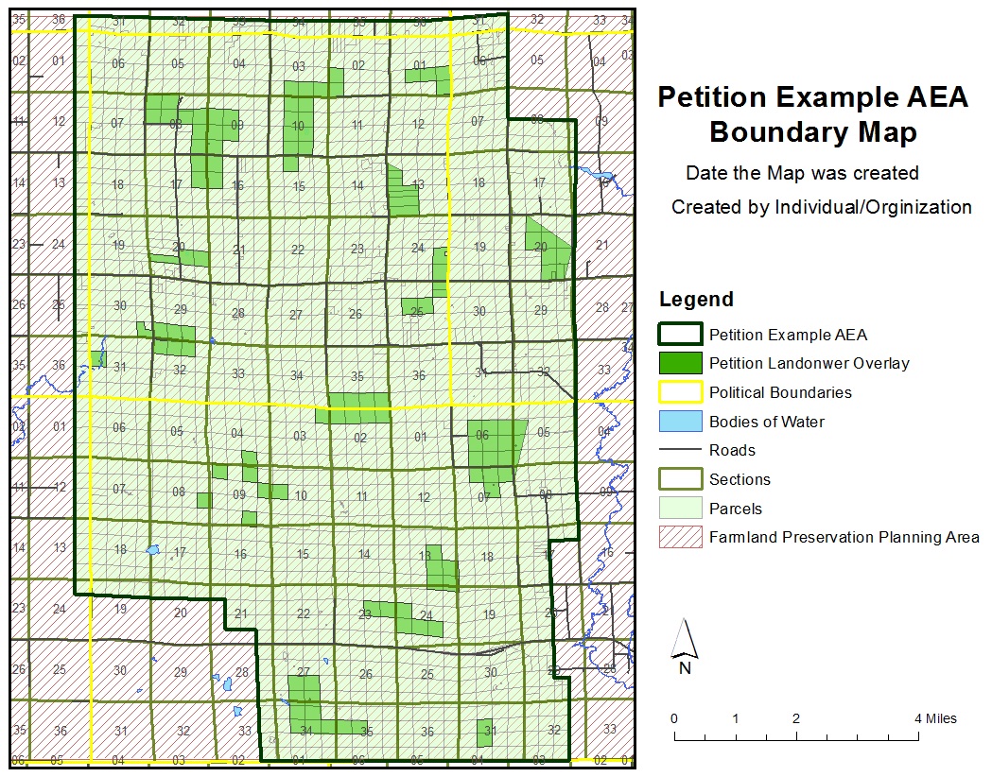

Application continued on the next page.

8. PHOTOS AND ADDITIONAL SUPPORTING DOCUMENTATION
INSTRUCTIONS:
Photos can be a great way to provide additional context to your petition.
Please include at least one photo of the proposed AEA that illustrates the agricultural resources within the community. Please note, any photos that are submitted to the DATCP may be used in materials related to the AEA program or for the Farmland Preservation Program.
Additional information can also be submitted to further support your petition and narrative. Examples of additional supporting documentation can include: event flyers, advertisements for programing related to this AEA petition, informational/educational materials used at public meeting or events, maps (current or historic), news articles about the propose AEA or petition process, historic pictures, or any other materials that can support your narrative.

Application continued on the next page.

9. SIGNATURE PAGES
INSTRUCTIONS:
Fill out the required signature pages for this proposed AEA petition. The purpose of the signature pages is to show there is adequate support in the area by landowners, local governments and agricultural-related business for designation. The following signature pages are found at the back of this application: “Petitioning Landowner Signature Page”, “Political Subdivision Signature Page”, “County Conservationist Signature Page” and “Non-Petitioning Cooperator Signature Page.” A letter of support can be submitted in lieu of any signature page.
- Submit a minimum of five (5) “Petitioning Landowner Signature Page(s)”.
  - The amount of petitioners should make sense in light of the boundary size, and there should be a logical distribution of petitioners within the proposed boundary.
  - Five landowner petitioner signature pages are require but submitting additional petition signature pages shows increased landowner support for the petition.
- Submit a “Political Subdivision Signature Page” for each political subdivision within the proposed boundary. This includes both counties, towns, cities, villages, ETZ and any municipality the within proposed AEA boundary.
- Submit a “County Conservationist Signature Page” signed by the county conservationist for each county included within the proposed boundary.
- Submit “Non-Petitioning Cooperator Signature Page(s)” from supports of the proposed AEA who are not eligible to sign a “Petitioning Landowner Signature Page”.
  - A minimum of 3 signature pages/letters of support for non-petitioner cooperators is highly recommended.
  - Examples of non-petitioner cooperators include local UW-Extension educators, Co-ops, conservation groups, agricultural businesses, Producer Led-Groups, agronomists, agricultural suppliers, businesses, non-profits, Land Trusts, Regional Planning Commissions, etc.
Signature pages are located at the back of this application. For a digital signature page, please email DATCP at DATCPWorkingLands@Wisconsin.gov or visit the Farmland Preservation Program website at https://datcp.wi.gov/Pages/Programs_Services/AEAPetitionInfo.aspx.

Signature pages are located on the following pages.

Petitioning Landowner Signature Page

A separate signature page, in the following form, must be signed by the owner of each farm. An authorized individual may sign on behalf of a legal entity. If a farm is jointly owned by a legally married couple, both individuals must sign.

Farm owner (correct legal name(s) or legal name of business entity):

_____________________________________________________________________________

Type of business entity, if applicable (check one):
Individual or married couple LLC
Corporation Other (describe)
Partnership

Authorized signature: __________________________________________________ Date _______
Print name: __________________________________________________
Authorized signature: __________________________________________________ Date _______
Print name: __________________________________________________

Farm owner address (street, city, zip): _________________________________________________

E-mail OR Phone Number: _________________________________________________

I (we) currently claim a farmland preservation tax credit (either under farmland preservation zoning or through a farmland preservation agreement). | Yes | No | Don’t Know
I (we) are interested in maintaining our existing farmland preservation agreement or entering into a new farmland preservation agreement. (Note: To claim the farmland preservation tax credit under a farmland preservation agreement, the farm must meet state soil and water conservation standards.) | Yes | No | Maybe

Political Subdivision Signature Page
This signature page must be signed by an authorized officer or representative of every political subdivision (county, town, city or village) in which any part of the proposed AEA is included.

Political subdivision name: _________________________________________________

Type (check one): County Town City Village

Printed name of authorized officer or representative: _______________________________

Title of authorized officer or representative: _______________________________

Authorized signature: ____________________________________________ Date: _________

Principal mailing address: _________________________________________________

_________________________________________________

Phone number: _________________________________________________

E-mail address: _________________________________________________

County Conservationist Signature Page
All county conservationists for the county or counties in which the proposed AEA is located must sign a signature page. If a single AEA is located across multiple counties, a separate signature page is required for the county conservationist in each county.

County Conservationist name: _________________________________________________

Authorized signature: ____________________________________________ Date: _________

Principal mailing address: _________________________________________________

_________________________________________________

Phone number: _________________________________________________

E-mail address: _________________________________________________

Non-Petitioner Cooperator Signature Page

Persons or entities other than the petitioners may sign in support of the petition. These persons/entities can include local UW-Extension educators, Co-ops, conservation groups, agricultural businesses, Producer Led-Groups, agronomists, agricultural suppliers, non-profits, Land Trusts, Regional Planning Commissions, or any other person or group with an interest in protecting local agriculture. A separate signature page, or letter of support, may be submitted for each cooperator. An authorized individual may sign on behalf of a legal entity.

Legal name of cooperator: _________________________________________________

Relevant interest (farm owner, business, nonprofit or community organization, government entity, other):

Principal mailing address: _________________________________________________

E-mail OR Phone Number: _________________________________________________

Briefly describe your interest in signing this petition requesting designation of an agricultural enterprise area:

Print name: _____________________________________________________________________

Authorized signature: _______________________________________________ Date ________
Appendix A. Sample Timeline
Timeframe | Activity
December 2021 – February 2022 | - Identify coordinator to help with petition process  - Identify other potential AEA partners  - Host public informational meeting(s) on AEAs  - Form AEA petition committee  - Find mapping assistance  - Review certified farmland preservation plan map  - Begin to draw boundaries
February – March 2022 | - Hold public meeting(s) to gather input, identify petitioners and get petitioner signature pages  - Hold petition committee meeting to work on map and petition content  - Start to get signature pages and letters of support
March – April 2022 | - Request DATCP sponsor a petition workshop  - Continue to work on petition and to collect signature pages  - If passing resolutions, get on agendas to have resolutions passed in April or May
May 2022 | - Continue to work on petition  - Continue to collect signature pages and letters of support  - Hold petitioner meeting to review petition draft
May – June 2022 | - Host final public meeting on petition content and AEA boundary
June – July 29, 2022 | - Double check petition to ensure completeness  - Send final petition to DATCP for evaluation by AEA evaluation team
August 2022 | - Petitions evaluated
Fall 2022 | - Recommended areas announced  - Order designating areas signed by department  - Notice of order published in the official state newspaper
January 1, 2023 | - Designations become effective  - Eligible landowners may enter into a farmland preservation agreement

Appendix B. Creating the AEA Boundary
When creating the boundary for your AEA, there are three rules you need to follow: 1) the boundary must follow parcel lines, 2) the boundary must be contiguous, and 3) all petitioning landowners must be included within the boundary.
In order to cluster farmland and prevent isolated islands of farmland, the AEA boundary must be contiguous. This means that the parcels included in the boundary share common boarders and are not otherwise separated except by roads, utility right-of-ways and/or bodies of water. A common misconception about the AEA is that all of the landowners who join the petition as petitioners have to be contiguous. This is not the case; in fact your boundary will be strengthened if the petitioning landowners are well distributed throughout the proposed boundary.
When looking at parcels to include to create the contiguous boundary, to the extent possible, the boundary should exclude publicly owned lands, such as DNR managed lands, federally owned land and town and county owned lands. These areas may be included to connect blocks of farmland, but the included public land should be minimal. In addition, try to minimize areas of privately owned woodland or wetlands that are not in agricultural use or otherwise associated with agricultural land, especially if the owners of this land are not eligible to claim the farmland preservation tax credit on these acres.
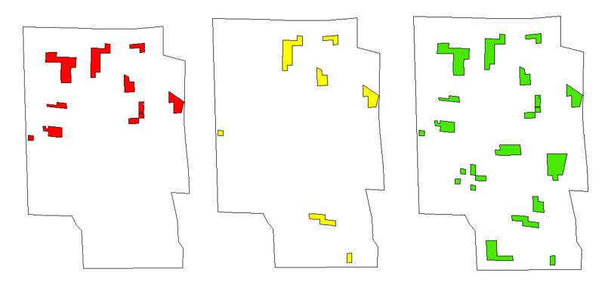Petitioning landowners should all be represented within the boundary. The boundary should include land owned by each of the petitioning landowners. You should also consider the number of petitioners and their distribution throughout the proposed boundary. The number of petitioners should be reasonable to support the proposed size (acres) and they should be logically distributed throughout the proposed boundary. Below are some examples of an AEA boundary with different number of petitioner participation and distributions.
Example 2: There are a low number of petitioners represented in the boundary but they are well distributed throughout the boundary. Additional petitioners should be identified to strengthen the boundary.
Example 3: There are a high number of petitioners represented in the boundary and they are well distributed throughout the proposed boundary.
Example 1: There a high number of petitioners represented in the boundary but they are not well distributed throughout the boundary. The boundary should be drawn closer to the petitioners.
The boundary, like the petition, should be developed through a public process, with the help of public meetings or open houses. When developing the boundary, try to involve other stakeholders and experts, including local and regional economic development specialists, county UWEX agents, county conservation staff, and local and regional planning organizations. Public involvement aids in identifying the appropriate boundary and ensures local support for the petition while reducing the potential for boundary errors.

Guidance available at: https://datcp.wi.gov/Pages/Programs_Services/AEAPetitionInfo.aspx
Personal information you provide may be used for purposes other than that for which it was collected, s. 15.04(1)(m), Wis. Stats.

