DAD-BARP-006.docx 12/22
  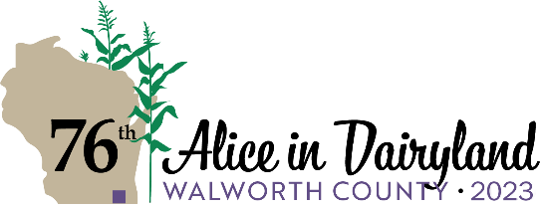 |  |  |  |  | Wisconsin Department of Agriculture,  Trade and Consumer Protection  Division of Agricultural Development  PO Box 8911, Madison, WI 53708-8911.  Phone: 608-224-4872 Fax: 608-224-4871
Alice in Dairyland Application
Complete all items below accurately. Print or type all information. Submit this application with a cover letter, resume, 150-word personal biography, and the contact information for three professional references to DATCPAlice@wisconsin.gov (preferred) or PO Box 8911, Madison, WI 53708-8911.
***All application materials must be received by DATCP by 4:30 PM on Friday, February 3, 2023***
You will receive confirmation of your submission.
- Contact Information
FIRST NAME |  | MIDDLE NAME |  |  | LAST NAME |  |  |  |  | DATE OF BIRTH
PREFERRED MAILING ADDRESS STREET |  |  |  | CITY |  |  |  |  |  |  | STATE |  | ZIP
HOME ADDRESS (If different mailing address) |  |  |  | CITY |  |  |  |  |  |  | STATE |  | ZIP
BUSINESS PHONE:  ( ) - | BUSINESS PHONE:  ( ) - |  | EMAIL |  |  |  | PREFERRED CONTACT METHOD (Select one)  Home Phone Cell Phone
- I am currently legally authorized to work in the United States. |  |  |  |  |  |  |  |  | Yes |  |  | No
- I am a Wisconsin resident. |  |  |  |  |  |  |  |  | Yes |  |  | No
- I have a valid Wisconsin Driver’s License. |  |  |  |  |  |  |  |  | Yes |  |  | No
If Yes, please provide your Wisconsin Driver’s License number:
- Certification Statement: I certify that the information I have provided in this application, cover letter, resume, three professional references, and summary of qualifications is true to the best of my knowledge. I understand that I may be required to verify information. I understand that any false, misleading, or missing information may disqualify me from employment consideration.
SIGNATURE |  |  |  |  |  |  |  | DATE

DATCP conducts the Alice in Dairyland program under its authority in Wis. Stat. § 93.07(3). Completing this form is voluntary. Personally identifiable information provided on this form may be used for purposes other than which is originally collected. Wis. Stat. § 15.04(1)(m).

