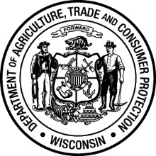

Retail Fueling Facility Compliance Training

For Owners and Operators

REGISTRATION FORM

Pre-registration is required for these training sessions. There is no fee to attend. Please note attendance at this training is optional. This training is not A/B Operator training.

☐ October 16, 2018 – 9:00 am ☐ October 18, 2018 – 10:00 am
Lussier Center UW Oshkosh - Sodexo Grand Ballroom 140A
3101 Lake Farm Road 625 Pearl Avenue
Madison Oshkosh

☐ October 23, 2018 – 10:00 am ☐ October 30, 2018 – 1:00 pm
Best Western - Milwaukee Airport Best Western Conference Center
Conference Center, Mitchell Ballroom 3340 Mondovi Road
5105 South Howell Avenue Eau Claire
Milwaukee

*Please note this is a fillable form. Just click the grey boxes to type.

Company/Organization:

Email (for registration confirmation):

Attendees:

Please return this form to Lily Castonguay no less than one week prior to the training session you would like to attend:

Lily.Castonguay@wisconsin.gov or DATCP
Attn: Lily Castonguay
2811 Agriculture Dr.
PO Box 8911
Madison, WI 53708-8911

