VEB_18.docx 10/30 (previously DSPD fm1229)
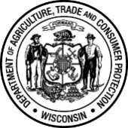 | Wisconsin Department of Agriculture, Trade and Consumer Protection  Veterinary Examining Board  2811 Agriculture Drive, PO Box 8911, Madison, WI 53708-8911  Phone: (608) 224-4353
COMMUNICABLE DISEASES CERTIFICATION FORM

Information Required by DHFS 145

I hereby certify that I am familiar with the State of Wisconsin health laws and rules of the Department of Health as related to communicable diseases.
Type of Credential (please print)
Application ID Number (please print)
Print Name of Applicant
 | / /
Signature of Applicant | Date

Committed to Equal Opportunity in Employment and Licensing

