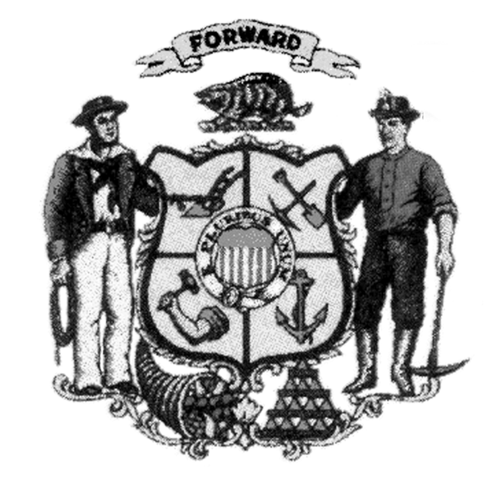
Land and Water Conservation Board
County Land and Water Resource Management Plan
Five Year Review of LWRM Plans
County:

Implementation Covering Past Five Years and Future Directions

Answer these four questions in writing (not to exceed 4 pages)

- Provide a representative number of accomplishments that can be directly traced to activities identified in multiple work plans. For each accomplishment, explain how the planning process helped the county achieve its outcome, including planning adjustments that helped better target county activities.

- Identify any areas where the county was unable to make desired progress in implementing activities identified in multiple work plans. For each area identified, explain the work plan adjustments that were made to refocus planned activities. If no areas are identified, explain how the county was able to make progress in all the areas planned.

- Describe how the county’s work plans implement its priority farm strategy and the effectiveness of county actions implementing agricultural performance standards and conservation practices on farms. In particular, the county should describe outreach, farm inventories, and additional funds that were pursued to implement its strategy.

- Provide representative examples that show changes in direction for work planning in the upcoming five years, with specific examples provided showing adjustments in planned activities in the county’s most recent work plan.

Annual Work Plans

Attach both of the following:

- The most current annual work prepared by the county.

- The work plan for the previous year that includes a column that identifies the progress in implementing the planned activities for that year.

Board Review Process

The goal of the review is not to fail counties. The board recognizes the dynamic nature of the planning process. Board members are interested in how counties tackle priorities over time and how they respond to changing conditions in pursuing their priorities. The board will evaluate a county’s planning and implementation based on how well the county balances and prioritizes the following: agricultural performance standards, other state priorities (impaired waters, FPP checks), and local priorities. When needed, the Board will provide constructive support to counties to improve the quality of their planning. Counties have the option to prepare a brief presentation to illustrate their successes and future priorities.

Land Conservation Committee Notification

The LCC was provided a completed copy of these questions (including attachments) on:

Signature of Authorized Representative: __________________________Date: __________
(e.g. County Conservationist, LCC chair)

Send completed questionnaire and attachments to:
Lisa.Trumble@wi.gov

